**To Supply Leftover Food to Poor**

## By Kanikicharla Jishitha

[jishitha.kanikicharla@gmail.com](mailto:jishitha.kanikicharla@gmail.com)

## PROJECT ABSTRACT

Food waste is a significant issue worldwide, with tons of food being discarded daily while many people suffer from hunger. This project aims to develop a Salesforce-based solution to streamline the process of collecting and distributing leftover food to those in need. By leveraging the capabilities of Salesforce, we can efficiently manage the logistics, ensure food safety,and maximize the impact of food donations.

This project will minimize food waste by redirecting surplus food to the poor, ensuring timely and efficient distribution. It will also enhance transparency through real-time tracking and reporting of food donations and distributions. Additionally, the project will engage volunteers and donors, facilitating their involvement in the food redistribution process.

The methodology involves integrating Salesforce CRM to create a centralised system for managing food donations, donors, volunteers, and beneficiaries. A portal will be developed for food establishments to register and report surplus food. Volunteers will be coordinated through a registration and assignment module to ensure-efficient food pick-up and delivery. A system will be implemented for identifying and registering individuals and communities in need of food assistance. Logistics management will be optimised using Salesforce's capabilities, and real-time tracking will be enabled through Salesforce's reporting and dashboard features. A feedback mechanism will be incorporated to continuously improve the process.

Expected outcomes include a significant reduction in food waste from participating establishments, improved food access for needy individuals and communities, higher participation rates from volunteers and donors, and clear and transparent reporting of all activities related to food collection and distribution. This Salesforce- based project addresses the dual issues of food waste and hunger by creating an efficient system for redistributing leftover food. By leveraging Salesforce's robust features, the project aims to create a sustainable and scalable solution that can be adopted by communities worldwide.

## INDEX PAGE

|  |  |
| --- | --- |
| Topics | Page no |
| Salesforce Developer Account Creation | 5 |
| Objects creation | 7 |
| Tabs | 12 |
| The Lightning App | 13 |
| Fields creation | 16 |
| Flows | 32 |
| Trigger | 35 |
| Profiles | 37 |
| Creation of Users | 38 |
| Public Groups | 40 |
| Report Types | 42 |
| Reports | 43 |
| Dashboards | 45 |
| Sharing Rules | 48 |
| Home Page | 50 |

**INTRODCTION**

Food waste is a growing concern globally, with an alarming amount of edible food being discarded daily while millions of people suffer from hunger and food insecurity. This paradox highlights the need for innovative solutions to bridge the gap between surplus food and those in need. The project "Supply Leftover Food to the Poor" aims to address this issue by leveraging the powerful capabilities of Salesforce to create a streamlined, efficient, and scalable system for collecting, managing, and distributing leftover food.

The core idea is to develop a centralised platform where restaurants, cafes, and other food establishments can easily report their surplus food. Volunteers can then be coordinated to collect and deliver this food to registered beneficiaries, ensuring that the food reaches those in need promptly and safely. By using Salesforce's CRM tools, we can enhance the efficiency of this process, track real-time data, and maintain transparency throughout the operation.

This project not only aims to reduce food waste but also seeks to improve food security for disadvantaged individuals and communities. Through community engagement and leveraging technology, we can create a sustainable model that benefits both the environment and society. By addressing logistical challenges and ensuring proper food handling and distribution, this project hopes to set a precedent for how technology can be used to tackle pressing social issues.

## TASK 1: Salesforce developer account creation

### Creating Developer Account

Creating a developer org in salesforce.

Go to <https://developer.salesforce.com/signup>2. On the sign up form, enter the following details :

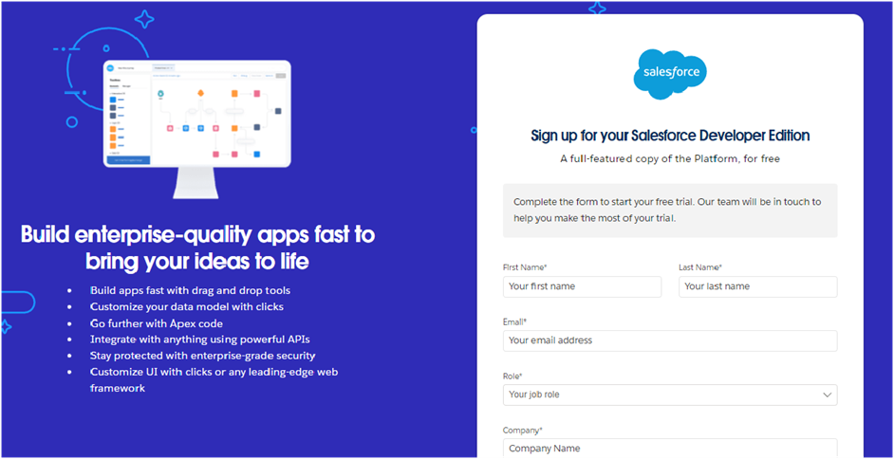

* 1. First name & Last name
  2. Email
  3. Role : Developer
  4. Company : College or Company Name
  5. County : India
  6. Postal Code : pin code
  7. Username : should be a combination of your name and company This need not be an actual email id, you can give anything in the format :

[username@organization.com](mailto:username@organization.com)

Click on sign me up after filling these.

AccountActivation

1. Go to the inbox of the email that you used while signing up. Click on the verify account to activate your account. The email may take 5-10mins.

|  |  |
| --- | --- |
|  |  |
|  |  |

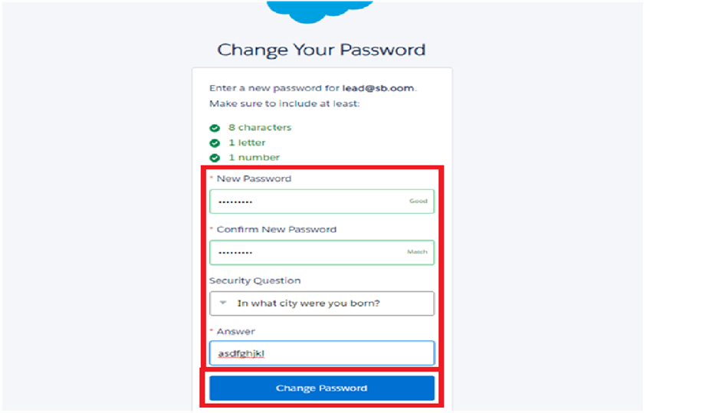

Click on Verify Account

2 . Give a password and answer a security question and click on change password.

3.Give a password and answer a security question and click on change password.

4.Then you will redirect to your salesforce setup page.

|  |  |
| --- | --- |
|  |  |
|  |  |

## TASK 2: Objects creation

## Create Venue Object

To create an object:

1. From the setup page >> Click on Object Manager>> Click on Create >>Click on Custom Object.
2. Enter the label name >> Venue
3. Plural label name >>Venues
4. Enter RecordName Label and Format
   1. Record Name >> VenueName
   2. Data Type >> Text
5. Click on Allow reports and Track Field History,Allow Activities.
6. Allow search>> Save. 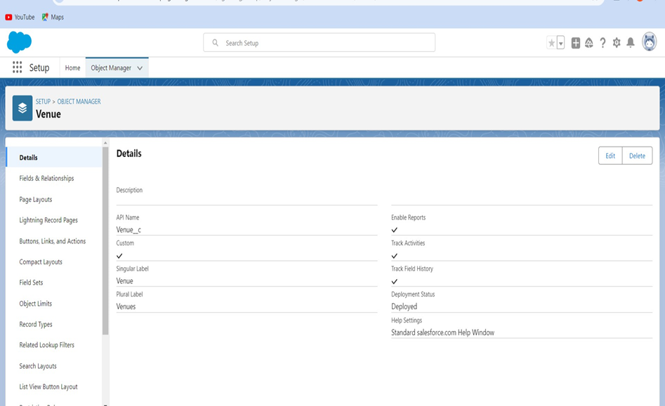

Create Drop-Off Point Object

To create an object:

1. From the setup page >> Click on Object Manager >>Click on Create >> Click on Custom Object.
2. Enter the label name >> Drop-OffPoint
3. Plural label name>> Drop-OffPoints
4. Enter RecordName Label and Format
   1. Record Name >> Drop-Offpoint Name
   2. DataType >> Text
5. Click on Allow reports and Track Field History,Allow Activities
6. Allow search>> Save.

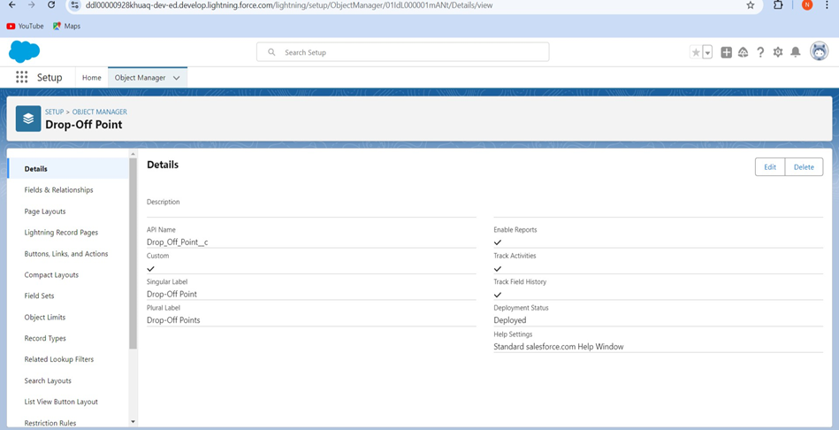

### Create Task Object

To create an object:

1. From the setup page >> Click on Object Manager >>Click on Create >> Click on Custom Object.
2. Enter the label name>> Task
3. Plural label name>> Tasks
4. Enter RecordName Label and Format
   1. Record Name >> Task Name
   2. Data Type >> Text
5. Click on Allow reports and Track Field History,Allow Activities
6. Allow search>> Save.

### 

### Create Volunteer Object

To create an object:

1. From the setup page >> Click on Object Manager>> Click on Create>> Click on Custom Object.
2. Enter the label name>> Volunteer
3. Plural label name>> Volunteers
4. Enter RecordName Label and Format
   1. Record Name >> VolunteerName
   2. Data Type >> Text
5. Click on Allow reports and Track Field History, Allow Activities
6. Allow search>> Save

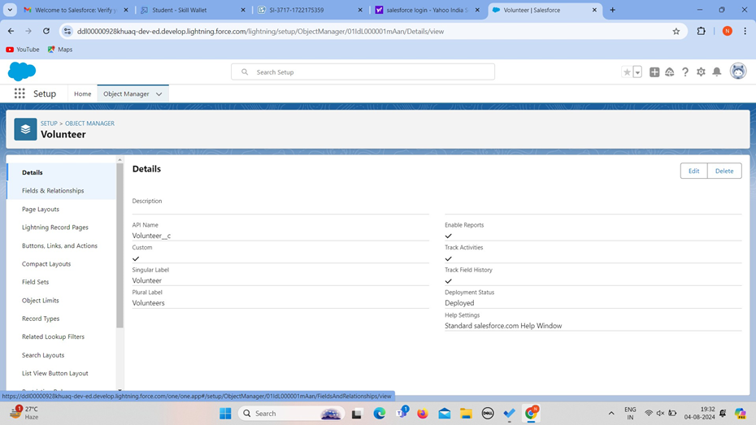

Create Execution Details Object

To create an object:

1. From the setup page >> Click on Object Manager >>Click on Create >> Click on Custom Object.
2. Enter the label name >>Execution Detail
3. Plural label name >> Execution Details
4. Enter Record Name Label and Format
   1. Record Name >>Execution Detail Name
   2. Data Type >>Text
5. Click on Allow reports and Track Field History, Allow Activities
6. Allow search >>Save.

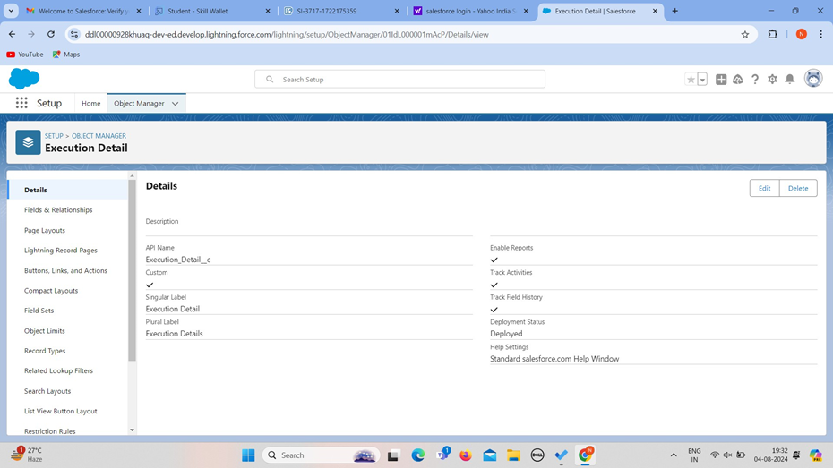

## TASK 3: Tabs

What is Tab : A tab is like a user interface that is used to build records for objects and to view the records in the objects.

Creating a Custom Tab

To create a Tab:(Venue)

Go to setup page >>type Tabs in Quick Find bar >>click on tabs >> New (under custom object tab)

1. Select Object(Venue) >> Select the tab style >> Next (Add to profiles page) keep it as default >> Next (Add to Custom App) uncheck the include tab .
2. Make sure that the Append tab to users' existing personal customizations is checked.
3. Click save

### Creating Remaining Tabs

1. Now create the Tabs for the remaining Objects,they are “Drop-OffPoint, Task, Volunteer, Execution Details”.

Follow the same steps as mentioned in above Activity.

|  |  |
| --- | --- |
|  |  |
|  |  |

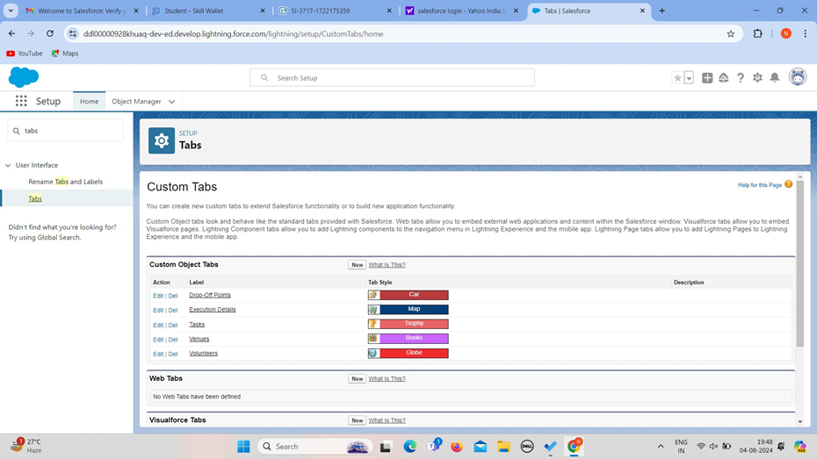

# TASK 4: The Lightning App

### To create a lightning app page:

1. Go to setup page >> search“app manager” in quick find >> select“app manager” >>click on New lightning App.

1. Fill the app name in app details and branding as follow App Name : FoodConnect

Developer Name : This will auto populated

Image : optional(if you want to give any image you can otherwise not mandatory) Primary colour hex value : keep this default.

1. Then clickNext >> (App option page)SetNavigation Style as Standard Navigation >> Next.

1. (Utility Items)keep it as default >>Next.
2. To Add Navigation Items:

Search for the item in the (Home, Venue, Drop-Off Point, Task, Volunteer, Execution Details, Reports) from the search bar and move it using the arrow button >> Next >> Next.

1. To Add User Profiles:

Search profiles (System administrator) in the search bar >> click on the arrow button >> save & finish.

|  |  |
| --- | --- |
|  |  |
|  |  |

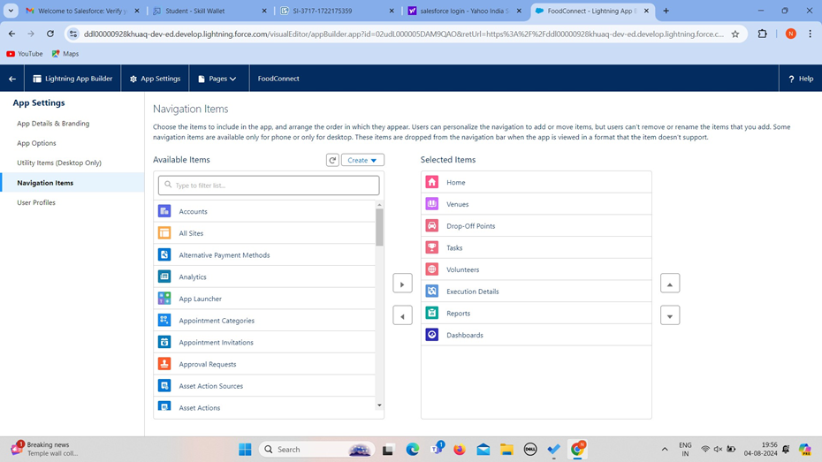

|  |  |
| --- | --- |
|  |  |
|  |  |

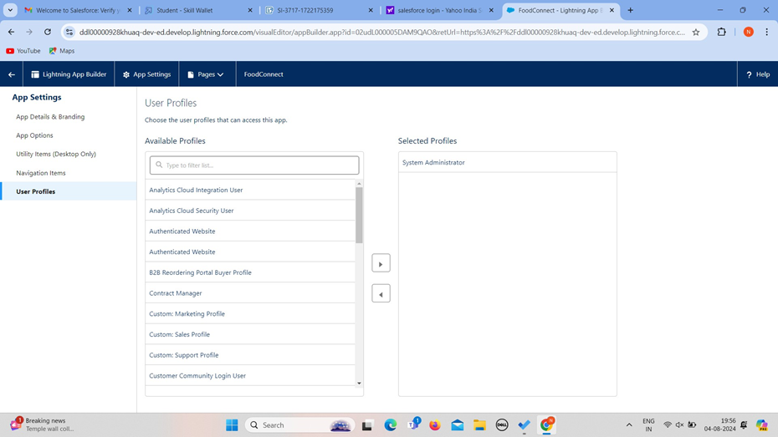

## TASK 5: Fields creation

### Creation of Relationship fields in objects

#### Creation of Lookup Relationship Field on Volunteer Object :

1. Go to setup>> click on Object Manager>> type objectname(Volunteer) in the search bar >> click on the object.
2. Nowclick on “Fields& Relationships” >>New
3. Select Master Detail relationship
4. Select the related object “Drop-Off point” and click next.
5. FieldName : Drop_Off_point
6. Fieldlabel : Auto generated
7. Next>> Next >> Save.

#### Creation of Master DetailRelationship Field on Execution DetailsObject :

1. Go to setup>> click on Object Manager>> type objectname(Execution Details) in the search bar >> click on the object.
2. Nowclick on “Fields& Relationships” >>New
3. Select Master Detail relationship
4. Select the related object“Volunteer” and click next.
5. Field Name : Volunteer
6. Field label : Auto generated
7. Next >>Next >> Save.

#### Creation of Master DetailRelationship Field on Execution DetailsObject :

1. Go to setup>> click on Object Manager>> type objectname(Execution Details) in the search bar >> click on the object.
2. Now click on “Fields & Relationships” >>New
3. Select Master Detail relationship
4. Select the related object“Task” and click next.
5. Field Name : Task
6. Field label : Auto generated
7. Next >>Next >> Save.

#### Creation of Lookup Relationship Field on Drop-OffPoint Object :

1. Go to setup>> click on Object Manager>> type objectname(Task) in the search bar >> click on the object.
2. Now click on “Fields & Relationships” >>New
3. Select Lookuprelationship
4. Select the related object “Drop-Off Point” and click next.
5. Field Name : Venue
6. Field label: Venue c
7. Next >>Next >> Save.

#### Creation of Lookup Relationship Field on Task Object :

1. Go to setup>> click on Object Manager >>type object name(Task) in the search bar >> click on the object.
2. Now click on “Fields & Relationships” >>New
3. Select Lookuprelationship
4. Select the related object“Venue” and click next.
5. Field Name : Sponsored By
6. Field label : Auto generated
7. Next >>Next >> Save.

#### Creation of Lookup Relationship Field on Task Object :

1. Go to setup>> click on Object Manager >>type object name(Task) in the search bar >> click on the object.
2. Now click on “Fields & Relationships” >>New
3. Select Lookuprelationship
4. Select the related object “Drop-Off point” and click next.
5. Field Name : Drop-Offpoint
6. Field label : Auto generated
7. Next >>Next >> Save.

### Creation of fields for the Venue object

1. Go to setup>> click on Object Manager>> type objectname(Venue) in search bar >> click on the object.
2. Nowclick on “Fields& Relationships” >>New
3. Select Data type as a “Email”and Click on Next
4. Fill the Above as following:
   1. Field Label : ContactEmail
   2. Field Name : ContactEmail
   3. Click on required check box
   4. Click on Next >>Next >> Save and new.

#### To create another fields in an object:

1. Go to setup >>click on ObjectManager >> type object name(Venue) in search bar >> click on the object.
2. Nowclick on “Fields& Relationships” >>New
3. Select Data type as a “Phone”and Click on Next
4. Fill the Above as following:
   1. Field Label : ContactPhone
   2. Field Name : ContactPhone
   3. Click on required check box
   4. Click on Next >>Next >> Save and new.

#### To create another fields in an object:

1. Go to setup >>click on ObjectManager >> type object name(Venue) in search bar >>click on the object.
2. Nowclick on “Fields& Relationships” >>New
3. Select Data type as a “Geolocation” and Click on Next
4. Fill the Above as following:
   1. Field Label: Location
   2. Decimal Places: 4
   3. Field Name : Location
   4. Description : Enter the Geolocation of your Venue
   5. Click on Next >>Next >> Save and new.

#### To create another fields in an object:

1. Go to setup >>click on ObjectManager >> type object name(Venue) in search bar >> click on the object.
2. Now click on “Fields & Relationships” >>New
3. Select Data type as a “Long Text Area” and Click on Next
4. Fill the Above as following:
   1. Field Label : VenueLocation
   2. Field Name : Venue_Location
   3. Click on Next >>Next >> Save and new.

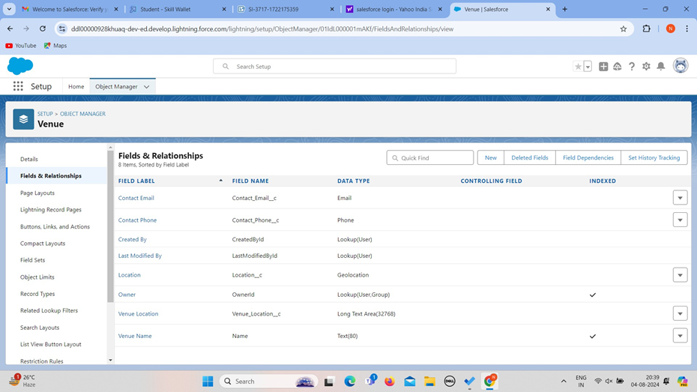

### Creation of fields for the Drop-Offpoint object

Go to setup>> click on Object Manager>> type objectname(Drop-Off point) in search bar >> click on the object.

1. Now click on “Fields & Relationships” >>New
2. Select Data type as a “Geolocation” and Click on Next
3. Fill the Above as following:
   1. Field Label : Location2
   2. Field Name : gets auto generated
   3. Description : Enter the Geolocation of the Drop off Point
   4. Geolocation Options : select Decimal
   5. Decimal Places : 4
   6. Click on Next >>Next >> Save and new.

#### To create another fields in an object:

1. Go to setup>> click on Object Manager>> type objectname(Drop-Off point) in

search bar >>click on the object.

1. Nowclick on “Fields& Relationships” >>New
2. Select Data type as a “Formula” and Click on Next
3. Fill the Above as following:

->Field Label : distance calculation

->Field Name : distance_calculation

->Formula Return Type : Number

->Formula Options : DISTANCE(Location_2 c , Venue r.Location c , 'km')

->Click on Next >>Next >> Save and new.

#### To create another fields in an object:

1. Go to setup >>click on ObjectManager >> type object name(Drop-Off point) in search bar >> click on the object.
2. Nowclick on “Fields& Relationships” >>New
3. Select Data type as a “Picklist” and Click on Next
4. Fill the Above as following:

FieldLabel : State

Field Name : State

Enter values, with each value separated by a new line :

Andhra Pradesh

ArunachalPradesh

Assam

Bihar Chhattisgarh Goa

Gujarat Haryan

Himachal Pradesh Jharkhand Karnataka

Kerala

Maharashtra

Madhya Pradesh Manipur Meghalaya

Minora Langland Odisha Punjab

Rajasthan

Sikking

Tamil Nadu Tripura Telangana

Utter Pradesh Tartaraghan West Bengal

Andaman & Nicobar(UT) Chandigarh (UT)

Dada & NagarHaveli and Dam an& Die (UT) Delhi [National Capital Territory (NCT)]

Jammu & Kashmir(UT) Lakh (UT) Lakshadweep (UT)

Puducherry (UT)

->Clickon required check box

->Clickon Next >>Next >> Save and new.

#### To create another fields in an object:

1. Go to setup >>click on Object Manager >>type object name(Task) in search bar >> click on the object.
2. Now click on “Fields & Relationships” >>New
3. Select Data type as a “Number”and Click on Next
4. Fill the Above as following:

->Field Label: Distance

->Field Name : Distance

->Length : 14

->Decimal Places : 4

->Clickon required check box

->Clickon Next >>Next >> Save and new.

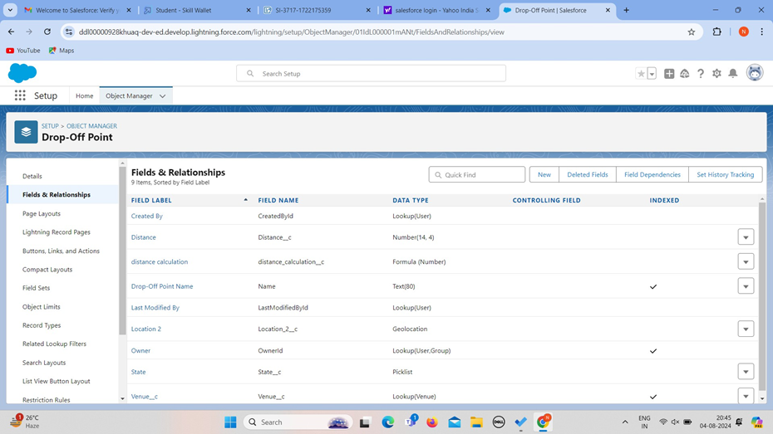

|  |  |
| --- | --- |
|  |  |
|  |  |

Creation of fields for the Task object

Go to setup>> click on ObjectManager >> type object name(Task) in search bar >> click on the object.

1. Now click on “Fields & Relationships” >>New
2. Select Data type as a “Auto Number” and Click on Next
3. Fill the Above as following:
   1. FieldLabel : Task ID
   2. Display Format : TASK-{0}
   3. Starting Number: 1
   4. FieldName : gets auto generated
   5. Click on required check box
   6. Click on Next >>Next >> Save and new.

#### To create another fields in an object:

1. Go to setup >>click on Object Manager >>type object name(Task) in search bar >> click on the object.
2. Nowclick on “Fields& Relationships” >>New
3. Select Data type as a “Date”and Click on Next
4. Fill the Above as following:
   1. Field Label: Date
   2. Field Name : Date
   3. Click on required check box
   4. Click on Next >>Next >> Save and new.

#### To create another fields in an object:

1. Go to setup >>click on Object Manager >>type object name(Task) in search bar >> click on the object.
2. Nowclick on “Fields& Relationships” >>New
3. Select Data type as a “Picklist(Multi-Select)” and Click on Next
4. Fill the Above as following:
   1. Field Label : Food Category
   2. Field Name : Food Category
   3. Enter values, with each value separated by a new line : Veg,Non-veg,snack,salad
   4. Click on required check box
   5. Click on Next >>Next >> Save and new.

#### To create another fields in an object:

1. Go to setup >>click on Object Manager >>type object name(Task) in search bar >> click on the object.
2. Now click on “Fields & Relationships” >>New
3. Select Data type as a “Number”and Click on Next
4. Fill the Above as following:
   1. Field Label : Numberof People Served
   2. FieldName : Number_of_People_Served
   3. Click on required check box
   4. Click on Next >>Next >> Save and new.

#### To create another fields in an object:

1. Go to setup >>click on ObjectManager >> type object name(Task) in search bar >> click on the object.
2. Now click on “Fields & Relationships” >>New
3. Select Data type as a “Text”and Click on Next
4. Fill the Above as following:
   1. Field Label: Name of the Person
   2. Field Name : Name_of_the_Person
   3. Click on Next >>Next >> Save and new.

#### To create another fields in an object:

1. Go to setup>> click on Object Manager >>type object name(Task) in search bar >> click on the object.
2. Now click on “Fields & Relationships” >>New
3. Select Data type as a “Phone”and Click on Next
4. Fill the Above as following:
   1. Field Label: Phone
   2. FieldName : Phone
   3. Click on Next >> Next>> Save and new.

#### To create another fields in an object:

1. Go to setup >>click on ObjectManager >> type object name(Task) in search bar >> click on the object.
2. Now click on “Fields & Relationships” >>New
3. Select Data type as a “Pick List” and Click on Next
4. Fill the Above as following:
   1. FieldLabel : Rating
   2. Field Name : Rating
   3. Enter values, with each value separated by a new line : 1

2

3

4

5

* 1. Click on Next >>Next >> Save and new.

#### To create another fields in an object:

1. Go to setup >>click on ObjectManager >> type object name(Task) in search bar >> click on the object.
2. Now click on “Fields & Relationships” >>New
3. Select Data type as a “Long Text Area” and Click on Next
4. Fill the Above as following:
   1. Field Label: Feedback
   2. FieldName : Feedback
   3. Click on Next >>Next >> Save and new.

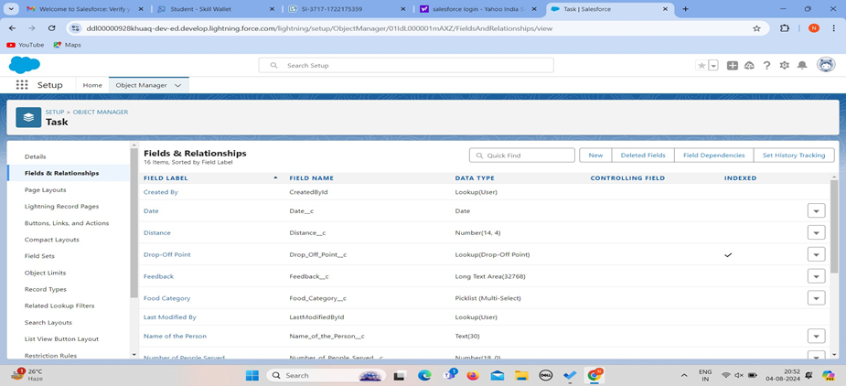

|  |  |
| --- | --- |
|  |  |
|  |  |

Creation of fields for the Volunteer object

1. Go to setup >>click on ObjectManager >> type object name(Volunteer) in search bar >> click on the object.
2. Now click on “Fields & Relationships” >>New
3. Select Data type as a “Auto Number” and Click on Next
4. Fill the Above as following:
   1. Field Label : VolunteerID
   2. Field Name : gets auto generated
   3. Click on required check box
   4. Click on Next >>Next >> Save and new.
   5. Click on Next >>Next >> Save and new.

#### To create another fields in an object:

1. Go to setup >>click on ObjectManager >> type object name(Volunteer) in search bar >> click on the object.
2. Nowclick on “Fields& Relationships” >>New
3. Select Data type as a “Picklist” and Click on Next
4. Fill the Above as following:
   1. FieldLabel : Gender
   2. Field Name : Gender
   3. Enter values, with each value separated by a new line : Female

Male

* 1. Click on Next >>Next >> Save and new.

#### To create another fields in an object:

1. Go to setup >>click on ObjectManager >> type object name(Volunteer) in search bar >> click on the object.
2. Nowclick on “Fields& Relationships” >>New
3. Select Data type as a “Date”and Click on Next
4. Fill the Above as following:
   1. Field Label : AvailableOn
   2. Field Name : Available On
   3. Click on required check box
   4. Click on Next >>Next >> Save and new.

#### To create another fields in an object:

1. Go to setup >>click on ObjectManager >> type object name(Volunteer) in search bar >> click on the object.
2. Now click on “Fields & Relationships” >>New
3. Select Data type as a “Number”and Click on Next
4. Fill the Above as following:
   1. FieldLabel : Age
   2. Field Name : Age
   3. Click on required check box
   4. Click on Next >> Next>> Save and new.

#### To create another fields in an object:

1. Go to setup >>click on ObjectManager >> type object name(Volunteer) in search bar >> click on the object.
2. Now click on “Fields & Relationships” >>New
3. Select Data type as a “Email”and Click on Next
4. Fill the Above as following:
   1. Field Label: Email
   2. Field Name : Email
   3. Click on required check box
   4. Click on Next>> Next >> Save and new.

#### To create another fields in an object:

1. Go to setup >>click on ObjectManager >> type object name(Volunteer) in search bar >> click on the object.
2. Now click on “Fields & Relationships” >>New
3. Select Data type as a “Number”and Click on Next
4. Fill the Above as following:
   1. FieldLabel : Contact Number
   2. Field Name : Contact_Number
   3. Click on required check box
   4. Click on Next >>Next >> Save and new.

#### To create another fields in an object:

1. Go to setup >>click on ObjectManager >> type object name(Volunteer) in search bar >> click on the object.
2. Now click on “Fields & Relationships” >>New
3. Select Data type as a “TextArea (Long)” and Click on Next
4. Fill the Above as following:
   1. Field Label: Address
   2. Field Name : Address
   3. Click on Next >>Next >> Save and new.

#### To create another fields in an object:

1. Go to setup >>click on ObjectManager >> type object name(Volunteer) in search bar >> click on the object.
2. Now click on “Fields & Relationships” >>New
3. Select Data type as a “Date”and Click on Next
4. Fill the Above as following:
   1. Field Label: Date of Birth
   2. Field Name : Date_of_Birth
   3. Click on Next >>Next >> Save and new.

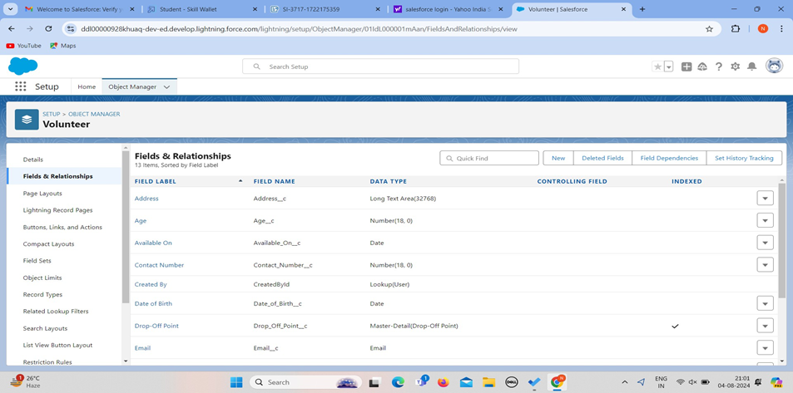

|  |  |
| --- | --- |
|  |  |
|  |  |

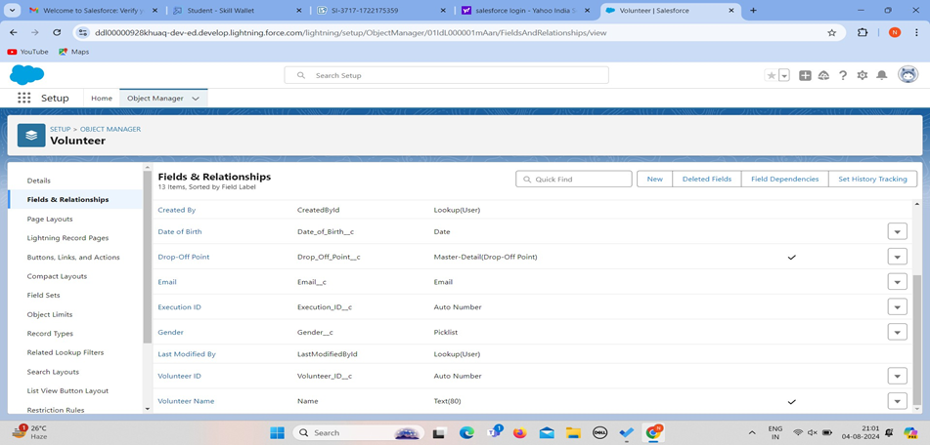

Creation of fields for the Execution Details object

1. Go to setup>> click on Object Manager>> type objectname(Volunteer) in search bar >> click on the object.
2. Now click on “Fields & Relationships” >>New
3. Select Data type as a “Auto Number” and Click on Next
4. Fill the Above as following:
   1. Field Label : Execution ID
   2. Field Name : gets auto generated
   3. Click on required check box
   4. Click on Next >>Next >> Save and new.

|  |  |
| --- | --- |
|  |  |
|  |  |

## TASK 6: FLOWS

### Create Flow to create a record in Venue object

1. Go to setup >>type Flow in quick find box >>Click on the Flow and Select the New Flow.
2. Select the Screen flow. Click on create.

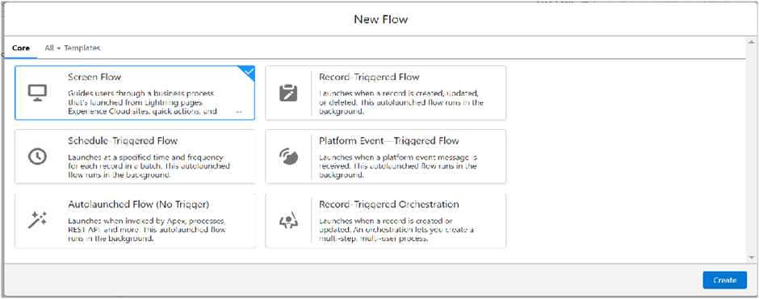

1. Click on the ‘+’ icon in between standard end, and click on screen element.
2. Under the Screen Properties: Label : Venue Details

API Name : Venue_Details

1. Now lets add components in this flow.Click on Text Component and name it as:

Label : Venue Name API Name : Venue_Name

1. Click on Email Component and name it as: Label : Email

API Name : Contact_Email

1. Click on Phone Component and name it as: Label : Phone

API Name : Contact_Phone

1. Click on Text Component and name it as: Label : Venue Location

API Name : Venue_Location

1. Click on Number Component and name it as: Label : Latitude

API Name : Latitude

1. Click on Number Component and name it as:

Label : longitude API Name : longitude

1. Next click on Done. This would like below

|  |  |
| --- | --- |
|  |  |
|  |  |

1. Click on the ‘+’ icon in between Venue details and end, and click on create record element.
2. Now label it as

Label : Create VenueRecord API Name : Create_Venue_Record

How Many Records to Create : One

How to Set the RecordFields : Use separate resources, and literal values

Object : Venue

Set Field Values for the Venue : Click on ‘Add Field’ 5 times Field : Value = Contact_Email c : {!Contact_Email.value}

Field : Value = Contact_Phone c : {!Contact_Phone.value} Field : Value = Name : {!Venue_Name}

Field : Value = Venue_Location c : {!location}

Field : Value = Location Latitude s : {!latitude}

Field : Value = Location Longitude s : {!longitude}

1. This would look like:

|  |  |
| --- | --- |
|  |  |
|  |  |

1. Click on Save as:

Flow Label : Venue Form

Flow API Name : Venue_Form

## TASK 7: Trigger

### Create a Trigger

Log into the trailhead account, navigate to the gear icon in the top right corner.

Click on developer console and you will be navigated to a new console window.

Click on the File menu in the toolbar,and click on new >>Trigger.

Enter the trigger name and the object to be triggered.

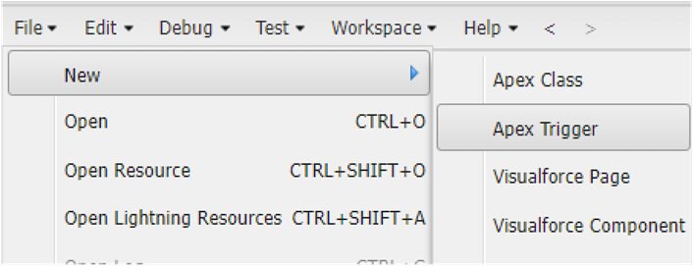

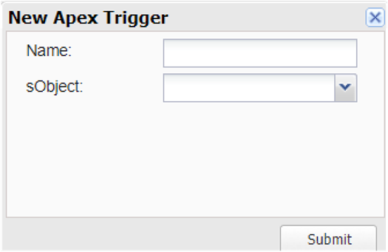

|  |  |
| --- | --- |
|  |  |
|  |  |

5. Enter Name :DropOffTrigger sObject: Drop-Off Point

6.Clickon Submit.

Trigger Code

(This Trigger is to assignDistance field to the DistanceCalculation field. So that we can assign the distance in the sharing rules.)

#### Code:

trigger DropOffTrigger on Drop_Off_point c (before insert){ for(Drop_Off_point c Drop : Trigger.new){

Drop.Distance c = Drop.distance_calculation c;

}

}

|  |  |
| --- | --- |
|  |  |
|  |  |

## TASK 8: Profiles

1. Go to setup page >> type Profiles in Quick Find bar >>click on Profiles>> click on ‘S’
2. Click on Clone beside Standard PlatformUser.
3. Under Clone Profile:

Profile Name : NGOs Profile

1. Then click on Save

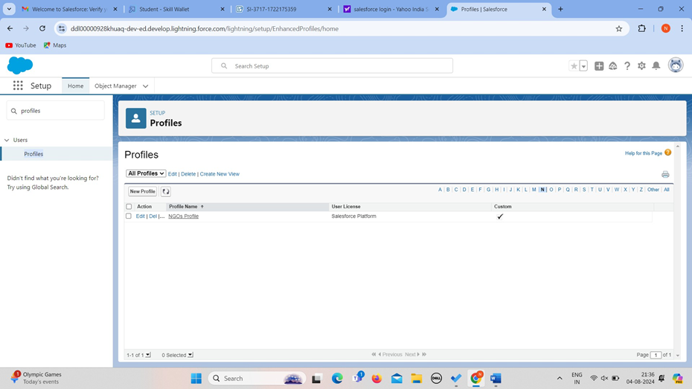

**TASK 9 : Creation of Users**

In our Projectwe consider them as NGO’s

### Creation of User1

1. Go to setup page >> type users in Quick Find bar >>click on users>> New user.
2. In GeneralInformation give details as: (Note : create users as per your wish NGO’s)

First Name : Akshaya Foundation Last Name : Iksha_Foundation Alias : sheikh

Email : Give Your Email

Username : [ikshafoundation@sb.com](mailto:ikshafoundation@sb.com) (give the username different) Nickname : Auto Populated

User License : Salesforce Platform Profile : NGOs Profile

Active : Check

|  |  |
| --- | --- |
|  |  |
|  |  |

1. Click on Save

Creation of User2, User3

Create another Two Users by following steps in Activity - 1 with similar User License and Profile.

Give Different First Name, Last Name based on Different NGO’s.

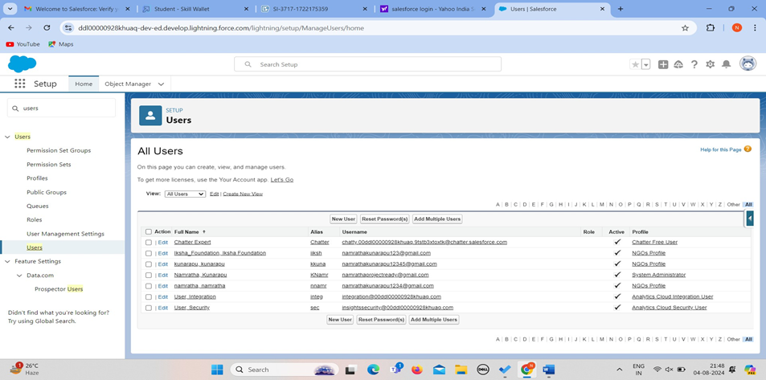

## TASK 10:Public Groups

### Creation of Public Group 1

1. Go to setup page >> type Public Groups in Quick Find bar >>click on Public Groups >> click on New.
2. Under GroupInformation: Label : Akshaya

Group Name : Iksha

Grant Access Using Hierarchies : Check

1. In Search,Select Users.
2. In SelectedMembers Add Akshaya Foundation and System Administrator

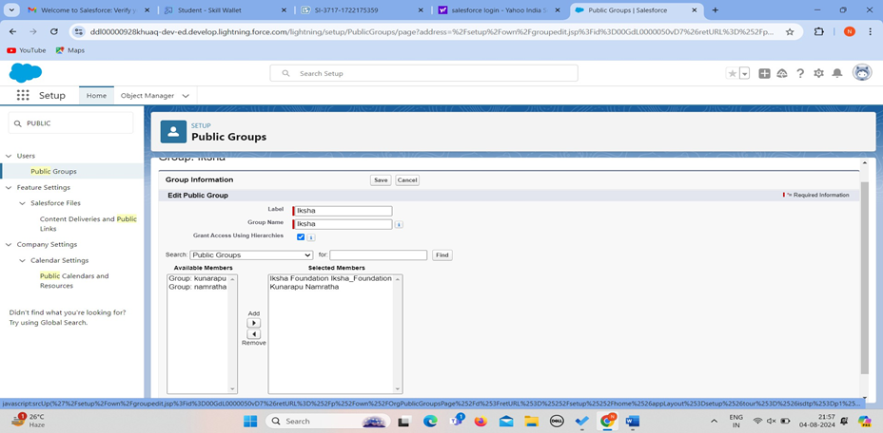

### Creation of Public Group 2

1. By FollowingSteps in Activity1, Create other two Public Groups for other two users.
2. AfterSaving this would look like this.

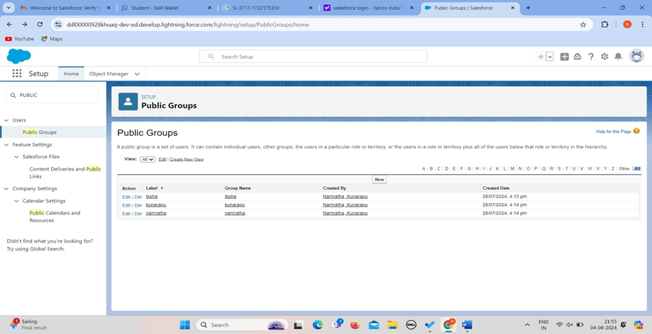

|  |  |
| --- | --- |
|  |  |
|  |  |

## TASK 11: Report Types

### Creation of ReportTypes

1. Go to setup page >> type Report Types in Quick Find bar >> click on Report Types >> click on Continue >>Click on New Custom Report Type.
2. In Define the Custom ReportType: Primary Object :Select Venues

Report Type Label : Venue with DropOff with Volunteer

Report Type Name : Venue_with_DropOff_with_Volunteer Description : Venue with DropOff with Volunteer

Store in Category: Select OtherReports Deployment Status : Deployed

1. Click on Next
2. Near Click to relate another Object Select Drop-Off Points.
3. And also select "A" records may or may not have related"B" records.
4. Now again Near Click to relate another Object SelectVolunteers.

|  |  |
| --- | --- |
|  |  |
|  |  |

1. Now click on Save

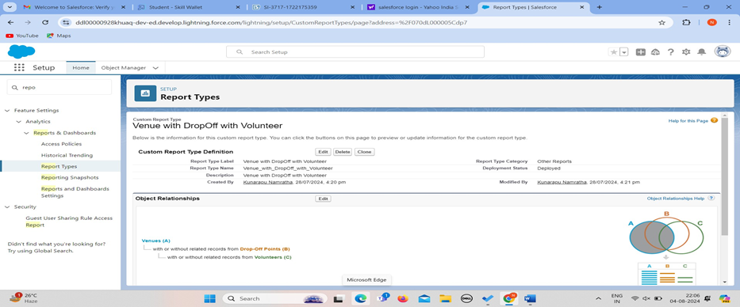.

## TASK 12:Reports

### Creation of Report on Venue with DropOff with Volunteer

1. Go to the app(FoodConnect) >> click on the reports tab
2. Click on New Folder.

Folder Label : Custom Reports

Folder Unique Name : CustomReports

1. Open CustomReports and click on New Report
2. Select ReportType : Venue with DropOffwith Volunteer
3. Then click on Start Report.
4. In GROUP ROWS : Add Volunteer Name
5. In Columns: Add Venue Name, Drop-Offpoint Name, Distance.
6. Now click on Save & Run.
7. GiveLabel as :
8. Report Name : venue and Drop Off point
9. Report UniqueName : Auto Populated
10. Click on Select Folder and select CustomReport, then click on Save.

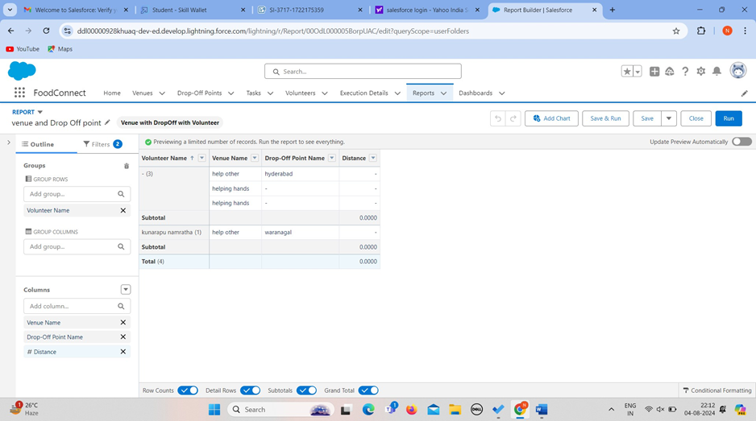

### Creation of Report on Volunteers with Execution Details and Tasks

1. Go to the app(FoodConnect) >> click on the reports tab
2. Click on Custom ReportsFolder and click on New Report
3. Select ReportType : Volunteers with ExecutionDetails and Tasks.
4. Then click on Start Report.
5. In GROUP ROWS : Volunteer ID
6. In Columns: Add Volunteer : VolunteerName, Task : Task Name, Execution Detail : Execution Detail Name, Volunteer: Owner Name, Task: Date, Task : Rating.
7. Now click on Save & Run.
8. GiveLabel as :

Report Name : Volunteer Task

Report Unique Name : Auto Populated

1. Click on Select Folder and select CustomReport, then click on Save.

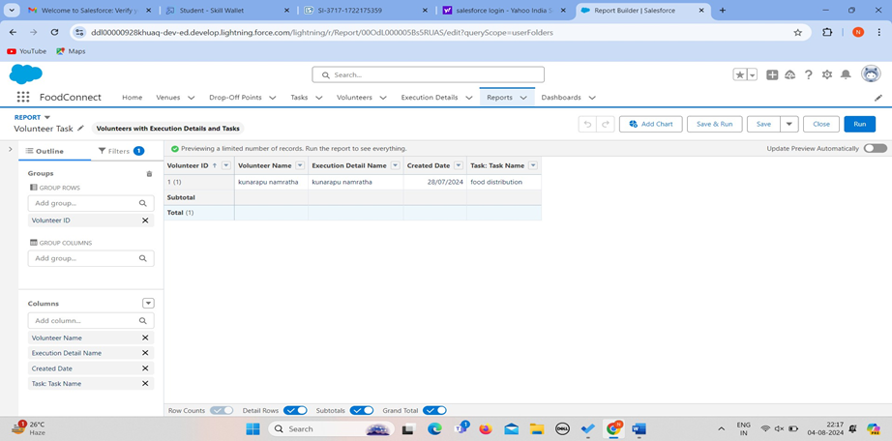

## TASK 13:Dashboards

### Adding venue and Drop Off point Report to the Dashboard

1. Go to the app(FoodConnect) >> click on the Dashboards tab.
2. Click on New Folder.

Folder Label : Custom Dashboards Folder Unique Name : Auto Populated

1. Open CustomDashboards and click on New Dashboards
2. Name : Organization Details
3. Click on Widget and select Chart or Table
4. In Select Report : Select venue and Drop Off point Report.
5. Then click on select
6. In Add Component:

Display As : Select Lightning Table Component Theme: Select Dark (Optional)

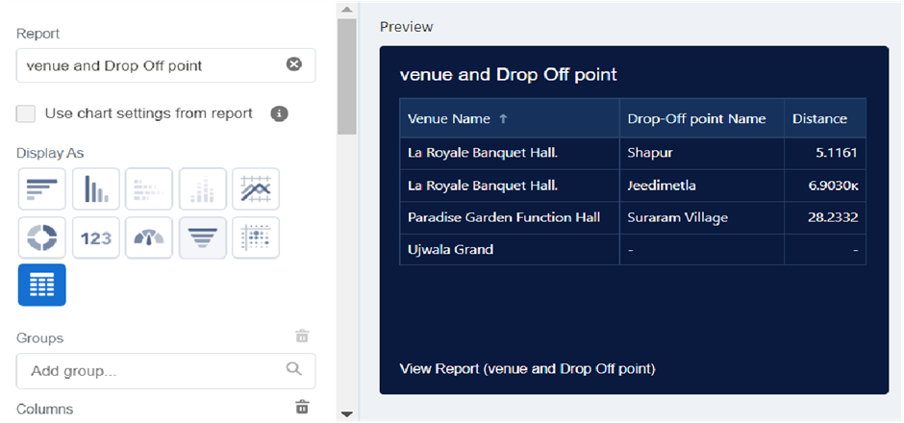

Now click on save.

### Adding Volunteer Task Report to the Dashboard

1. Click on Widget and select Chart or Table
2. In SelectReport : SelectVolunteer Task Report.
3. Then click on select
4. In Add Component:

Display As : Select Line Chart

Component Theme : Select Dark (Optional)

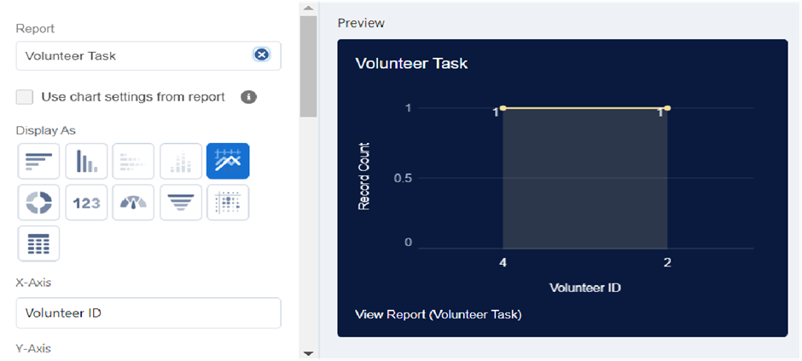

Now click on save.

### Adding a Picture to the Dashboard (Optional):

(Note : To upload an image into the Dashboard, we have to first download an image from google or other sources into your system)

1. Click on Widget and select Image.Then click on Browse Files.
2. Then Select the Picture you want to upload in this Dashboard.
3. Then click on Save As :

Name : Task Execution Details

Click on SelectFolder and selectCustom Dashboards

1. Click on Select Folder and then Save.

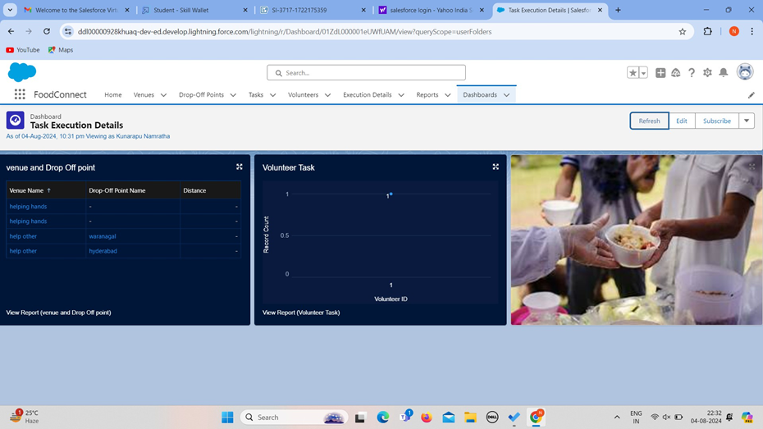

## TASK 14: Sharing Rules

### Creation of sharing rules

1. Go to setup >>type Sharing Settings in quick find box >>Click on the Sharing Settings.
2. Scroll down and find Drop-Off pointSharing Rules.
3. Click on new near Drop-Off pointSharing Rules and Name it as: Label : Rule 1

Rule Name : Rule_1

1. Select your rule type : SelectBased on criteria.
2. Select which records to be shared:

Field : Operator: Value = Distance : less than : 15

1. Select the users to share with : Near Share With Public Groups : Iksha
2. Click on Save.
3. Click on new near Drop-Off point Sharing Rules and Name it as:

Label : Rule 2

Rule Name : Rule_2

1. Select your rule type : SelectBased on criteria.
2. Select which records to be shared:

Field : Operator : Value = Distance : greater than : 15 Field : Operator: Value = Distance : less or equal : 30

1. Select the users to share with : Near Share With Public Groups : NSS
2. Click on Save.
3. Click on new near Drop-Off pointSharing Rules and Name it as: Label : Rule 3

Rule Name : Rule_3

1. Select your rule type : SelectBased on criteria.
2. Select which records to be shared:

Field : Operator : Value = Distance : greater than : 30 Field : Operator: Value = Distance : less or equal : 50

1. Select the users to share with : Near Share With Public Groups : Street Cause
2. Click on Save.

|  |  |
| --- | --- |
|  |  |
|  |  |

# TASK 15:Home Page

### Creation of Home Page

1. Go to setup >>type Lightning App Builder in quick find box >>Click on the Lightning App Builder and Select the New.
2. Select Home Page and give Label as HOME Page.
3. Select Standard Home Page.
4. Near Components search for Flow and Drag and Drop in Right Side Section..
5. On the right hand side:

Flow : VenueFlow

|  |  |
| --- | --- |
|  |  |
|  |  |

1. Near Components search for Dashboard, then Drag and Drop it in first Section.

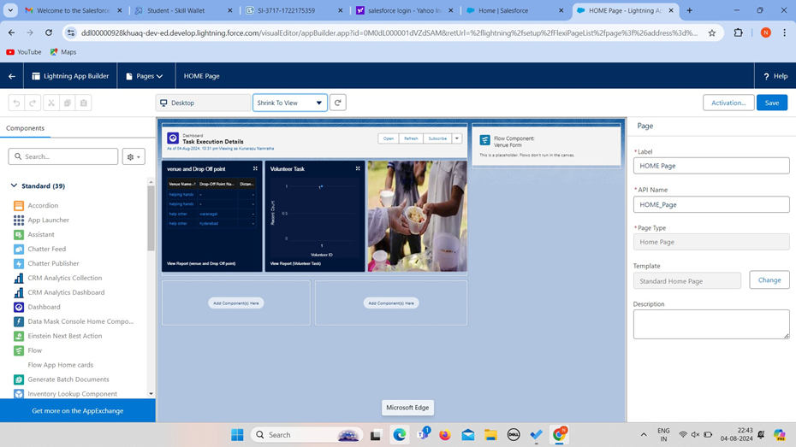

1. Click on Save and Activation, then click on App Default,then Add Assignments.
2. AddFoodConnect App and then Save.
3. FoodConnect Home Page would Look Like this.

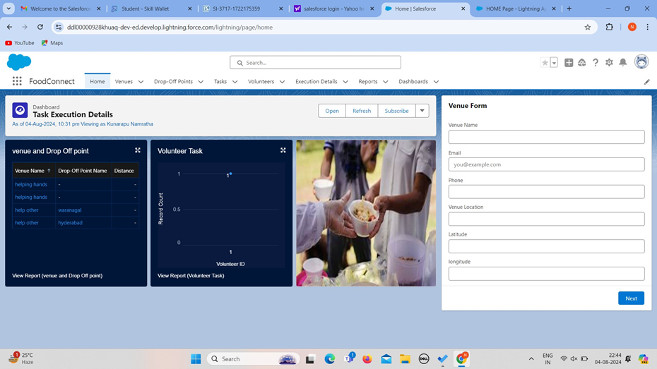

## Conclusion

By leveraging the Salesforce platform, the project successfully established a streamlined and transparent system for managing surplus food donations. Through efficient coordination with volunteers and timely delivery to beneficiaries, the project effectively addressed food insecurity while maximising the utilization of available resources.

|  |  |
| --- | --- |
|  |  |
|  |  |